KINGSTONE SSS END OF TERM TWO PHYSICS EXAMS

SENIOUR THREE

TIME 2 HOURS

ATTEMPT ALL NUMBERS

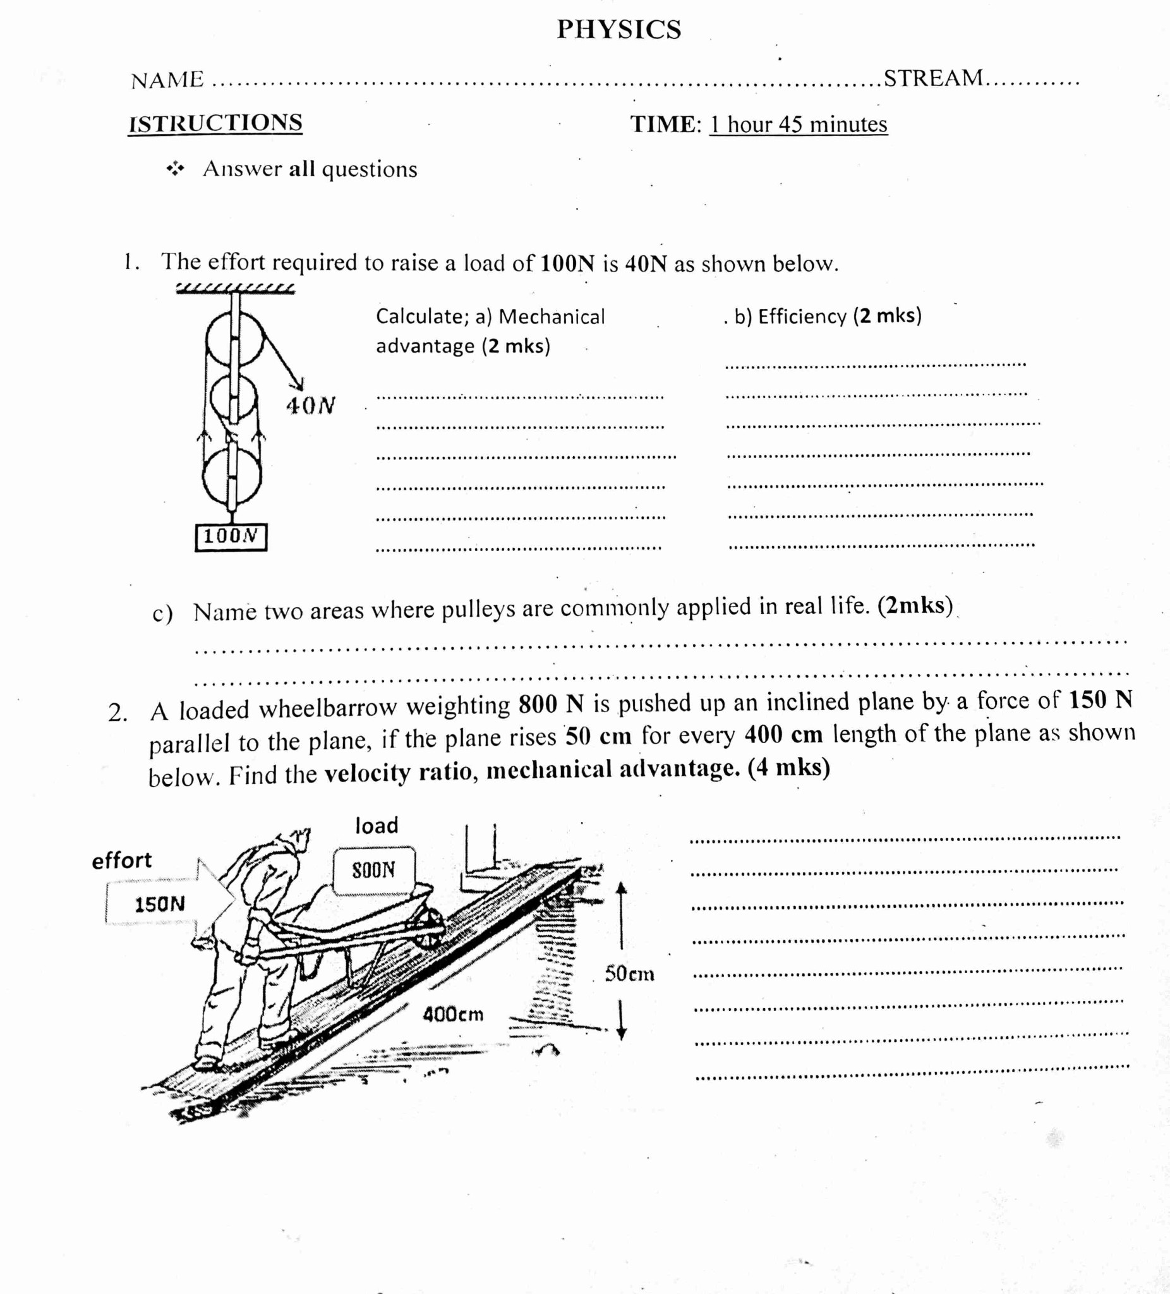

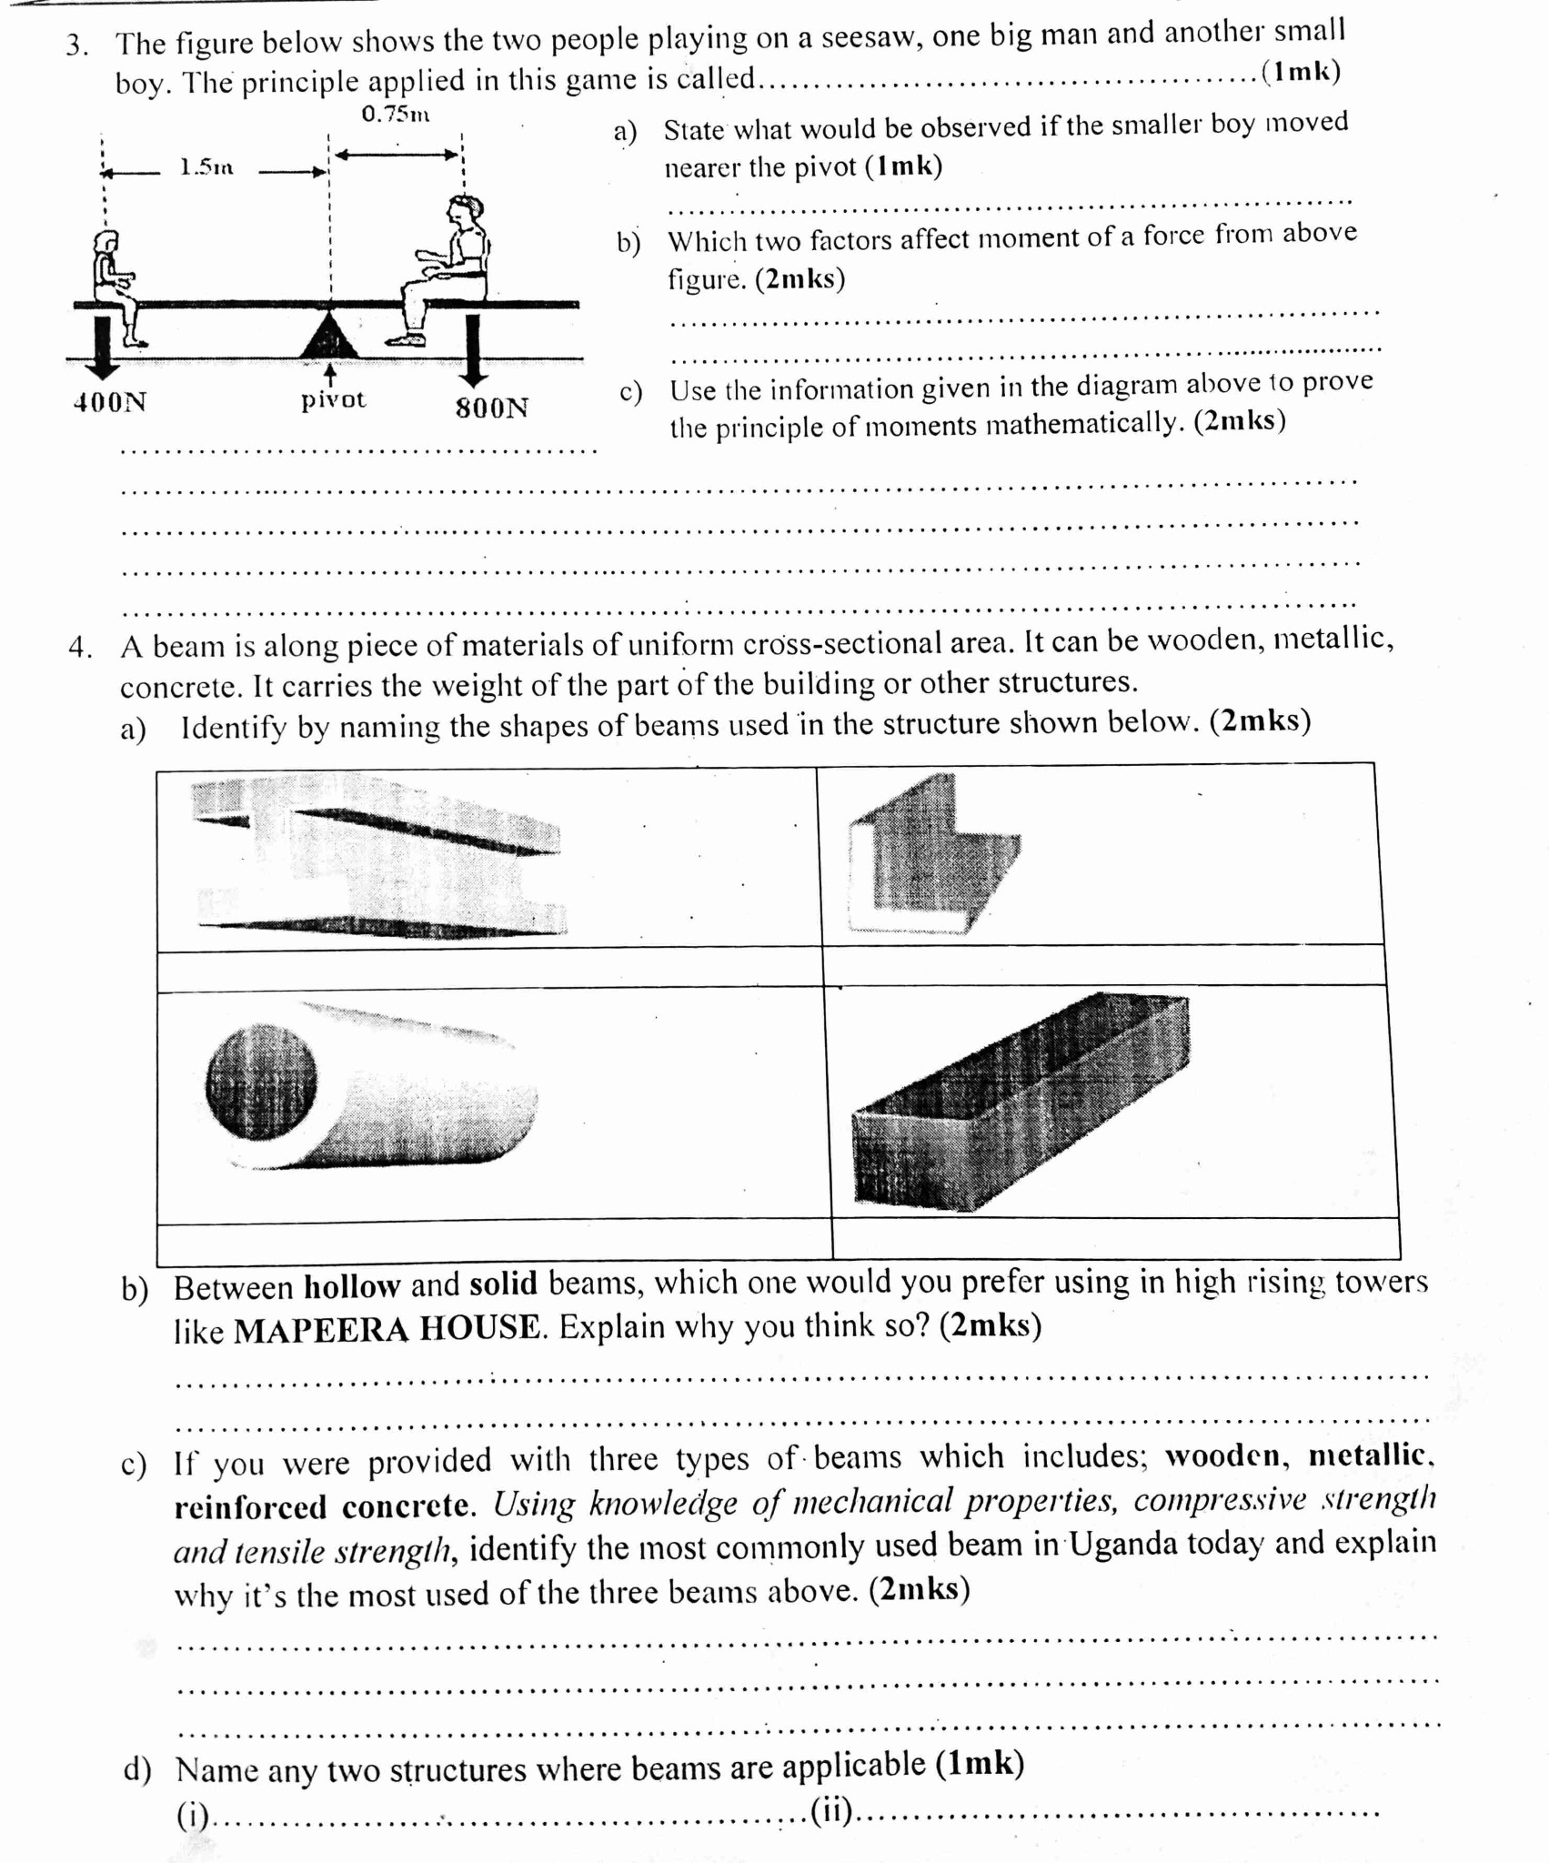

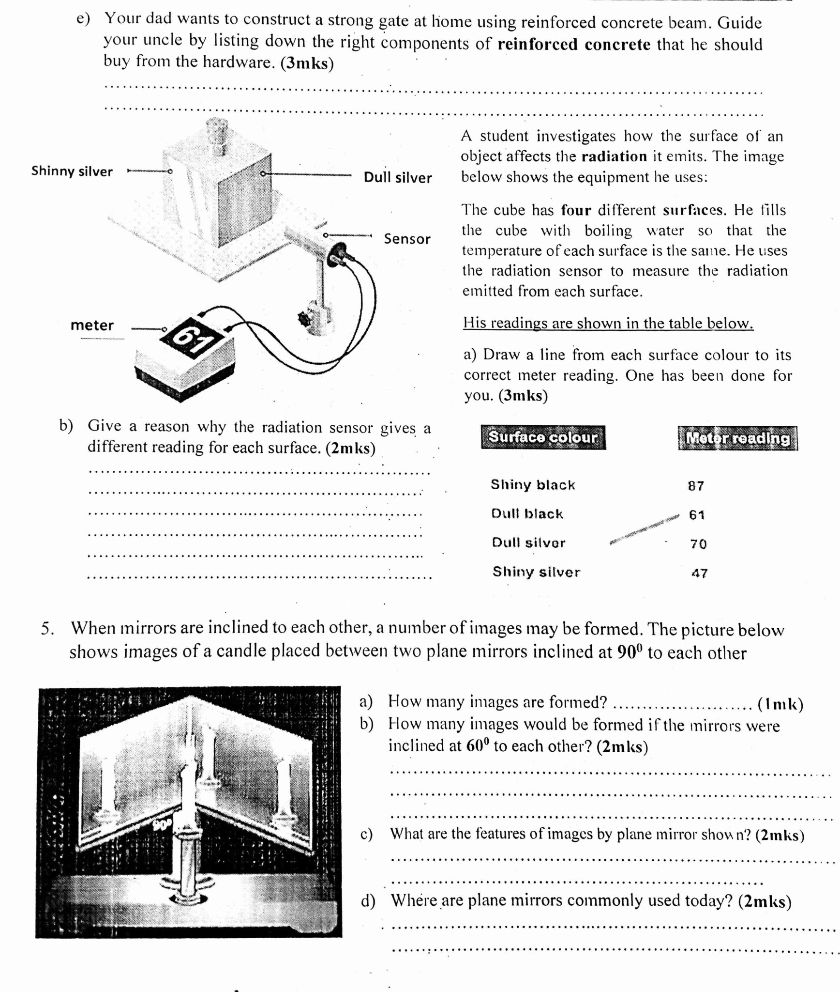

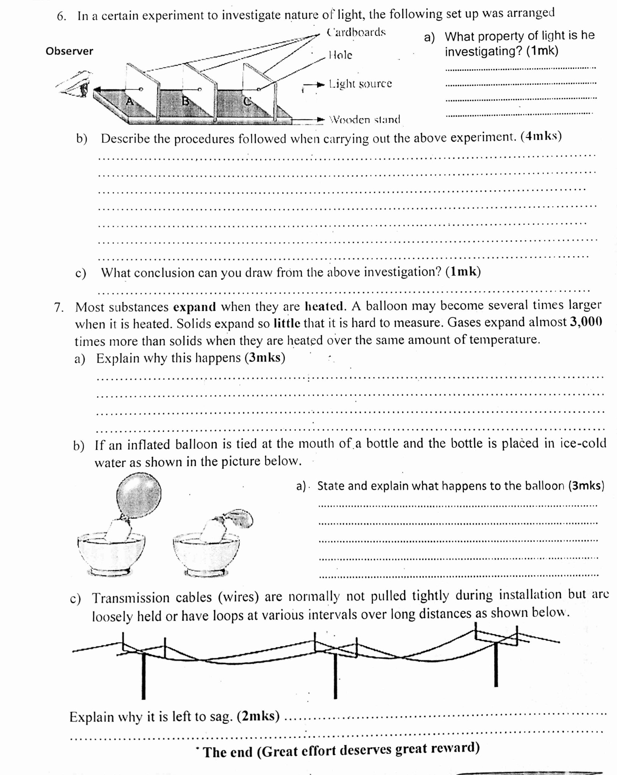EEEEEEEEEEEEEEE